IDEATION PHASE
Define The Problem Statement

Date | 31 January 2025
Team Id | LTVIP2026TMIDS36439
Project Name | Toycraft Tales Tableau's vision into Toy manufactures Data
Maximum Marks | 2 Marks

Customer Problem Statement Template:
Definition:
Toycraft Tales Tableau Vision Manufactures Data
It is the process of transforming raw toy manufacturing data—such as production costs, material waste, and assembly line efficiency—into interactive visual dashboards. Using Tableau, this vision aims to "tell a story" (Tales) through data, making complex manufacturing metrics easy to understand for stakeholders.

Purpose of Analyzing Toy Manufacture Data

- Operational Efficiency: To identify bottlenecks in the production line where toy assembly might be slowing down.

- Quality Control: To track defect rates across different toy categories and improve the manufacturing standards.

- Cost Management: To analyze the cost of raw materials (plastic, fabric, electronics) and find ways to reduce waste without compromising quality.

- Market Alignment: To see which toy designs are performing best in the market and adjust production schedules accordingly.
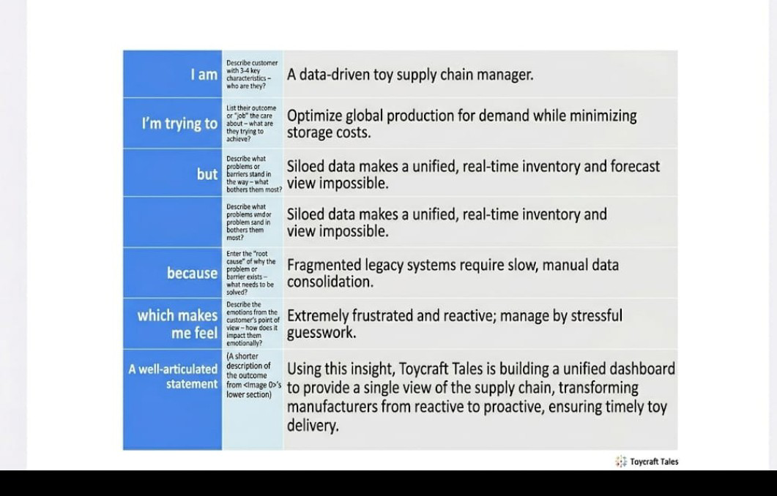

Reference :https://miro.com/templates/customer-problem-statement/

Example :
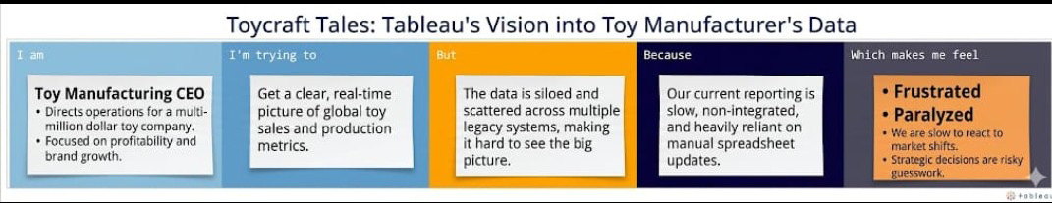

Problem statement (PS) | I am  (Customer) | I’m trying to | But | Because | Which makes me feel
PS-1 | Toy Manufacturing CEO | Get a clear, real-time picture of global toy sales and production metrics | The data is siloed and scattered across multiple legacy systems | Our current reporting is slow and heavily reliant on manual spreadsheet updates | Frustrated and Paralyzed
PS-2 | Supply Chain Manager | Optimize inventory levels to meet seasonal toy demand | I cannot see the "big picture" of current stock versus forecasted sales | Systems are non-integrated, making it hard to see real-time Data | Stressed and reactive to market shifts

